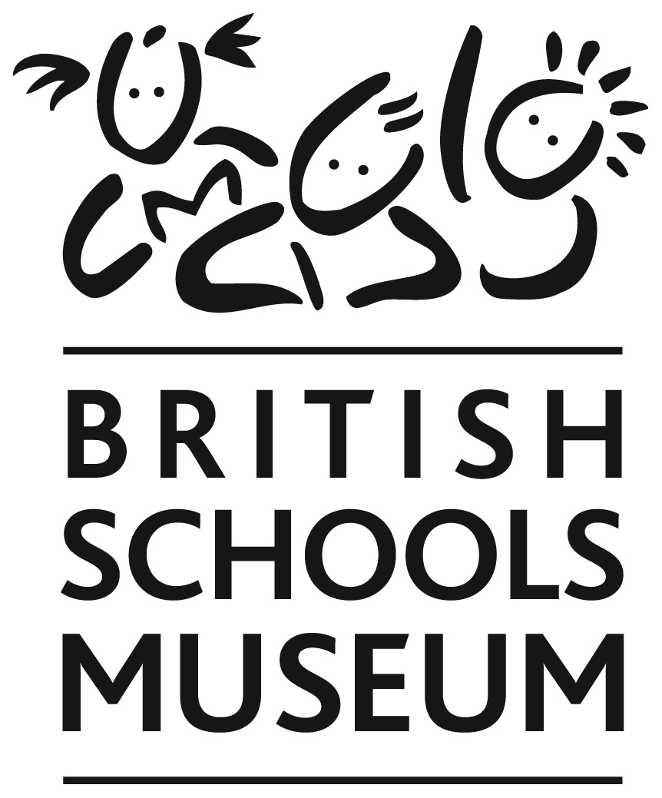

THE HITCHIN BRITISH SCHOOLS TRUST

Donation & Gift Aid

_____________________________________________________________________________________

Gift Aid legislation allows us to register all your donations and to claim back the tax you have already paid on this money.
This means we get an extra 25p for every pound you give, at no extra cost to you.

I enclose a donation of £..................

Mr. Mrs Miss Ms

Forename(s) ………………………… Surname: .....................................................

Address: …………………...………………………………………………………………

Postcode: .……………. Telephone: …………………………… (in case of query)

Cheques should be made payable to: Hitchin British Schools Trust.

Please sign the following declaration:
Please treat as Gift Aid donations all qualifying gifts of money made today, in the last four years, and in the future.
I confirm I have paid, or will pay, an amount of Income Tax and/or Capital Gains Tax for each tax year (6 April to 5 April) that is at least equal to the amount of tax that all the charities or Community Amateur Sports Clubs (CASCs) to which I donate will reclaim on my gifts for that tax year.
I understand that other taxes such as VAT and Council Tax do not qualify.
I understand the charity will reclaim 25p of tax on every £1 given on or after
6 April 2008.

Signature: ........................................................ Date: .........................................

Please hand this form and your donation to one of our volunteers, or send it to:
Finance Office, The British Schools Museum, 41/42 Queen Street,
Hitchin, Herts. SG4 9TS

Please contact us if you wish to cancel this declaration, change your name or home address, or no longer pay sufficient tax on your income and/or capital gains.
_____________________________________________________________________________________________________________

The Hitchin British Schools Trust is a Registered Charity No 1010345
The Trust will use your details above ONLY for purposes of claiming Gift Aid from HMRC and/or to contact you in relation to your donation.
© The Hitchin British Schools Trust 2014

Thank you very much for your donation

Every penny will help us to re-open the museum, welcoming back our visitors to a fresh, virus safe and socially-distanced museum

And by Gift Aiding your donation, your money will do 25% more!

Mark Copley
Curator

